**Internal Memo**

**TO:**

**TITLE:**

**ROOM:**

**ADDRESS:**

**FROM:** **Office Product Manager**

**DATE:**

**RE: ANNUAL PERFORMANCE MEETING**



**MEETING INVITATION**

Dear ,

The Office team would like to invite you to attend our Annual Performance Meeting in which we will evaluate the performance of Partners and Sales for our Region for the entire year.

The meeting will be held at the following time and place:

Location: Frontier Building, Block C, Sky Meeting Room, 1012

Time: 9.00am

Date: 10 June 2011

We would like to thank you for your attention and we look forward to presenting our results. Please take note that refreshments and a coffee break will be provided.

Written By

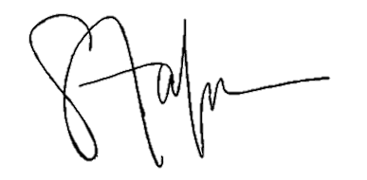

_________________________

Product Manager

Sales & Marketing Division

Action Pty Ltd